Wireshark Packet Analysis – Report

1. Title:
Wireshark Packet Analysis

2. Objective:
The objective of this task is to capture and analyze live network traffic using Wireshark and understand the behavior of different network protocols such as TCP, HTTP, and DNS. The task also involves identifying packet flow and checking for any abnormal or malformed packets.

3. Task Description:
In this task, I was assigned to perform network packet analysis using Wireshark. The goal was to capture real-time network traffic, apply protocol filters, and analyze communication between devices. This helps in understanding how data is transmitted over a network and how different protocols operate during communication.

4. Tools Used:
- Wireshark Network Analyzer
- Operating System (Windows/Linux)
- Active Internet Connection (Wi-Fi/Ethernet)

5. Methodology / Implementation:
- Wireshark application was opened and a live network interface was selected for packet capture.
- Packet capture was started to monitor real-time network traffic.
- Different protocol filters such as TCP, HTTP, and DNS were applied to analyze specific traffic types.
- TCP stream was analyzed to understand the three-way handshake process (SYN, SYN-ACK, ACK).
- DNS queries and HTTP requests were observed to understand request-response communication.
- Packet details were inspected to understand source, destination, protocol behavior, and data flow.
- A check was performed for malformed or abnormal packets using Wireshark filters.

6. Observations / Analysis:
- Multiple network packets were captured successfully during the session.
- TCP protocol communication clearly showed the three-way handshake process.
- DNS packets were observed, indicating domain name resolution activities.
- HTTP packets showed request and response communication between client and server.
- No critical abnormalities were observed in normal packet flow.
- Malformed packet filter was checked and no significant malformed packets were detected during the analysis.

7. Screenshots / Evidence:

HTTP:

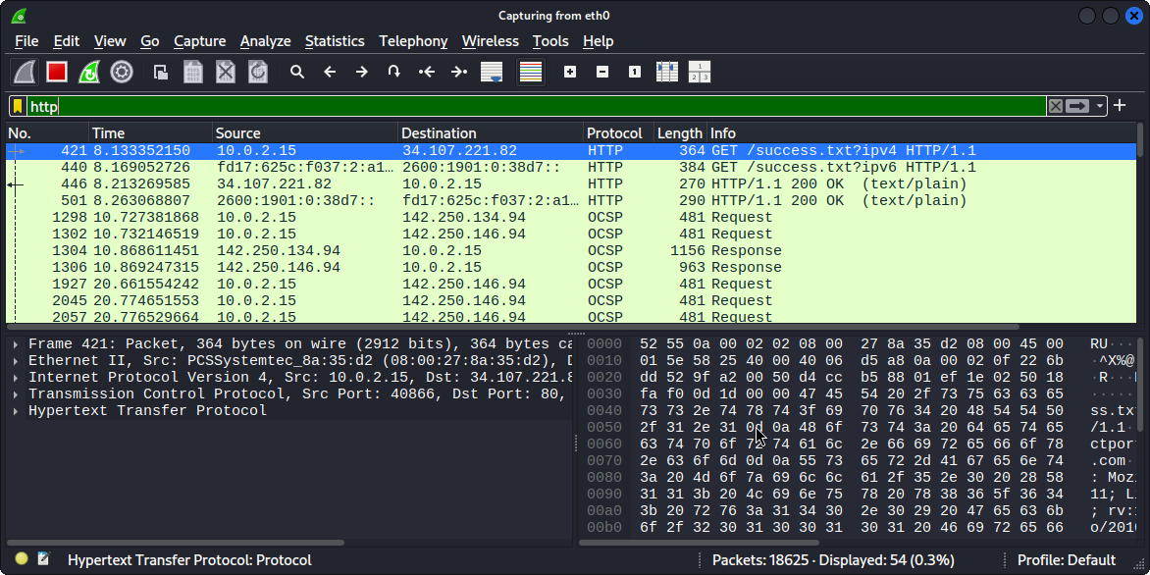

DNS:

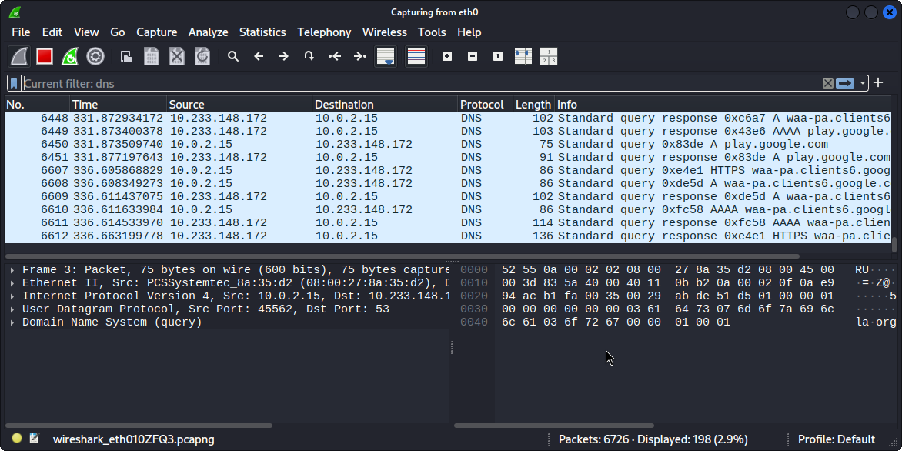

TCP Handshakes:

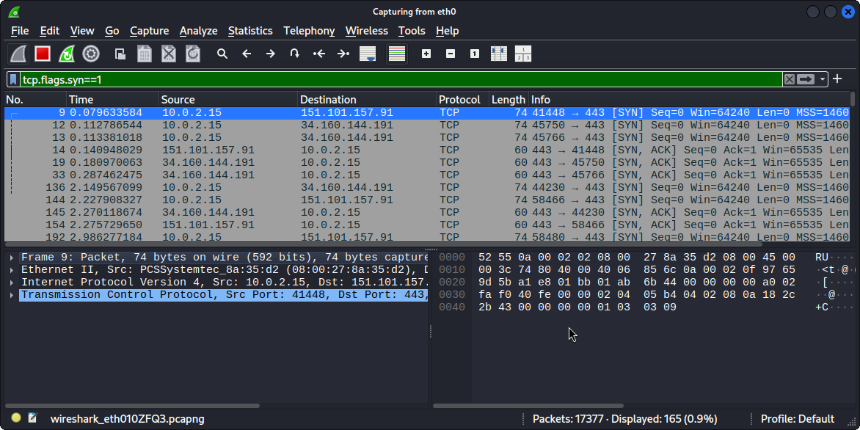

Malformed:

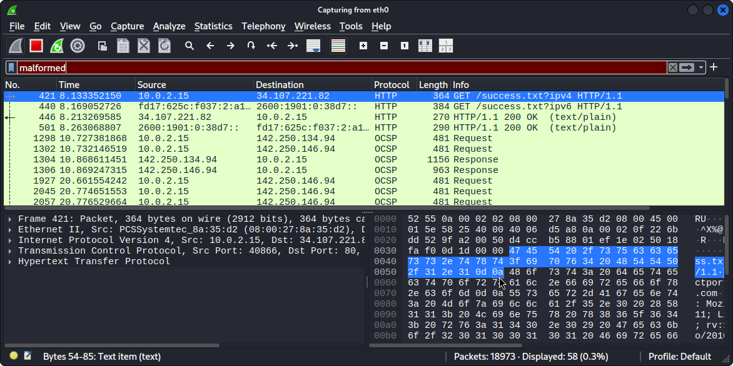

Example structure:
- Figure 1: HTTP
- Figure 2: DNS
- Figure 3: TCP three-way handshake analysis
- Figure 4: Malformed result (if applied)

8. Results / Findings:
The network traffic was successfully captured and analyzed using Wireshark. Different protocols such as TCP, HTTP, and DNS were identified and studied. The TCP connection establishment process was clearly observed through the three-way handshake. The packet flow between source and destination was understood effectively. No malformed or suspicious packets were detected during the analysis.

9. Conclusion:
This task provided practical exposure to network packet analysis using Wireshark. It helped in understanding how real-time network communication takes place and how different protocols operate in a network environment. The exercise improved knowledge of packet structure, protocol behavior, and traffic analysis techniques.

